**BRISTOL FIFE FANCY CANARY CLUB**

**Host**

**The BFFCC Annual Show**

**&**

**FIFE CANARY COUNCIL SHOW**

**North Star 240°**

**Long Cross,**

**Bristol,**

**BS11 0QA**

**Sunday 15th December 2024**

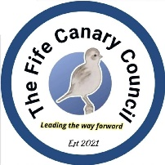

#### 

#### SHOW SECRETARY

#### Tom Marsh

#### 24 Overhill, Pill, Bristol, BS20 0JZ

### ENTRIES

Postal entries to be in the hands of the show secretary by Saturday 30th November 2024

You may also enter online using the google form on our facebook page. Simply download the entry form and upload to the form.

For the forgetful, late entries will be accepted by phone @ a charge of

£2.00 for Postage and admin until 8 PM on Friday 8th December.

For Telephone Entries Call **Tom** on 07538 159145

Please enclose a self addressed and stamped envelope with postal entries for the return of Cage Labels

Please Note : if labels do not arrive (lost in post) new labels will be issued on entering at the show hall, this is VERY EASY, not a problem

**Bristol FFCC Meetings are held every 2nd Sunday of the month.**

**Contact Tom on 07538159145**

**or**

**Email Bristolffcc@gmail.com**

### SHOW DETAILS

Judge: Henry Cooper, Matt Eld and Gerald Spencer

Birds will be accepted from APROXIMATELY 6.30 pm – 8.30pm on Saturday 14th and

7.30am – 9.00am Sharp on Sunday 15th December 2024

Judging will commence at 9.15am

ADMISSION

For Sales & Show Adults £1, Under 15s FREE.

CATALOGUES £2 for Bristol FFCC Lifting of the birds will begin approximately 4.00 pm

SUBSCRIPTIONS £5.00 for all (Adults, Partnerships and Juniors)

CAGE ENTRY COST :- £1.00 per cage Juniors FREE ADMISSION

DEFRA

With new legislation now in place, all birds have to be looked at before staging. Any bird showing signs of ill health will be refused and removed from the show halls. If you have any aviary with outdoor access or keep any type of poultry breed on the same premises as your canaries you must now register with DEFRA. This has also been extended to taking birds outside for any reason including taking birds to bird gatherings or shows. If you require any further information please visit APHA online, or contact us at Bristol FFCC.

Hotel Accommodation Details

Details correct at time of print,

Premier Inn, Cribbs Causeway

Cribbs Causeway, Catbrain Ln, Patchway, Bristol BS10 7T

£62 Based on Single Room per night

Approx 3.5 Miles from the venue.

0333 777 3958

Travel Lodge, Avonmouth

Central Park, Goldcrest Way, Severn Beach, Bristol BS35 4GH

£52 Based on Single Room per night

approx 7miles from venue

£52 / night

0871 984 6580

Ramada Bristol West – M5

M5, Junction 19, Portbury, Bristol, BS20 7XG

£72 Based on 1 / 2 adults for 1 night

Approx 5.3 Miles from the venue

01275 373709

Bradford Lodge LTD

149-151 Avonmouth Rd, Avonmouth, Bristol BS11 9LW

£55 based on single Room per night.

Approx 2miles from the venue

0117 982 321

**Bristol FFCC Show Rules for 2024**

|  |
| --- |
| All exhibitors agree to abide by the rules of the Bristol fife fancy canary club. |
| All birds must be the bona fide property of the exhibitor. |
| All birds are to be staged by 9.00am, on the day of the show, to enable judging to commence by 9.15am. no birds will be accepted after judging has commenced unless permission is granted by the show manager. |
| All birds are to be staged in a standard dewar show cage, with drinker and sufficient seed to last throughout the show, and with a floor covering of tierworl, chipsi gold chip original or soft chip. dirty cages will not be accepted. |
| Stewards and officials only are allowed in the show hall during judging. |
| This schedule is to be read carefully. no alterations on entry forms will be accepted, for any reason, or birds changed to other classes after the catalogue has been printed. |
| There will be an invoice sent to those exhibitors haven’t paid in full by the show day, including any costs of recovering outstanding monies due. |
| Any bird wrongly classed by the exhibitor will not be re-classed or cage labels be altered on the day of the show. |
| All entries to be checked by a steward. |
| The show committee reserve the right to appoint extra judges if necessity arises. |
| No bird is to be removed from the show hall without the show managers permission. |
| Judges will be instructed to disqualify dyed or trimmed birds. |
| Judge’s decision is final unless fraud or misrepresentation is proven. |
| Any exhibitor wishing to lodge a protest must deposit £10 to the show manager, no later than 90 minutes prior to the close of the show. their deposit will only be returned if the protest is upheld. the decision of the show committee is final. |
| Any person selling birds in the car park of the show hall do so at their own risk. the committee of the Bristol FFCC take no responsibility, as provision for selling birds and equipment is available in the show hall. |
| The committee has the right to refuse entry to any person not abiding by the show rules. |
| Any matter not covered in these rules will be referred to the show committee whose decision is final. |

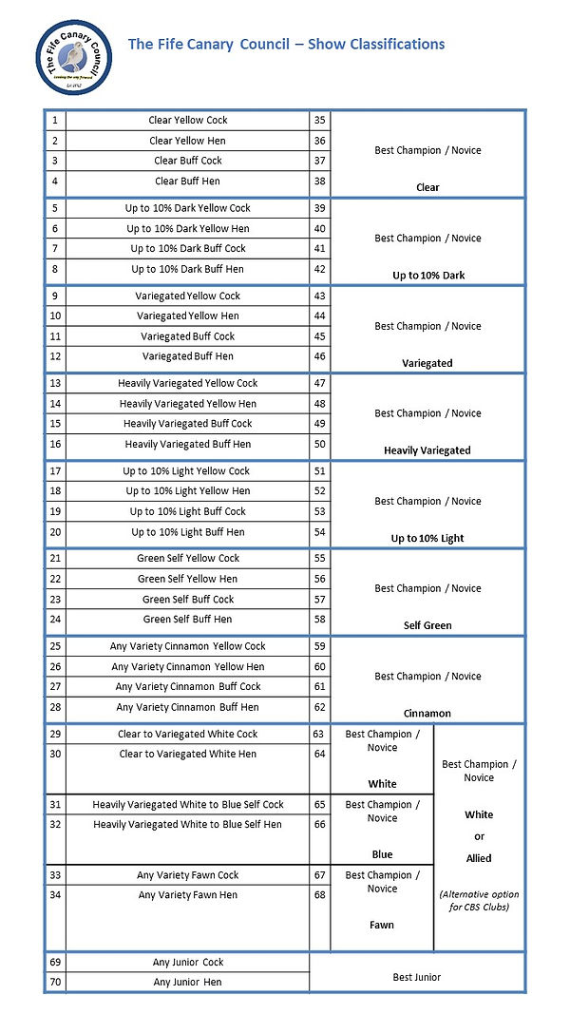

**AN AID TO SHOW CLASSIFICATION**

|  |  |
| --- | --- |
| Clear | A clear bird is one that has no dark feathers within its plumage. |
| Up to 10% dark | Is a clear bird that displays no more than 10% (in total) of dark feathers in its plumage. |
| Variegated | Is a bird that displays between 11% and 50% of dark feathers in its plumage. |
| Heavily variegated | Are birds that display some clear feather but have between 51% and 90% of dark feathers in their plumage. |
| Up to 10% light | Is a dark bird that displays no more than 10% (in total) of light feathers in its plumage. |
| Self | Is a bird that displays no clear feather in its plumage. it is natural, and therefore acceptable, for self-birds to display a small amount of lighter green feathering under their beak. |
| Cinnamon | Are birds that displays cinnamon feathering in their plumage. |
| White and Blue | Are white ground birds that display white or blue feathering in their plumage. |
| Fawn | A white ground bird that is marked with cinnamon variegation rather than blue. |
| Flighted birds | Are to be exhibited within the standard classifications |
| Novice rule | A novice exhibitor can remain a novice for as long as the fancier wishes and can move to champion status at any time. however,  they will be required to move up to champion status, the following show season, should they accumulate 10 best novice wins at fife canary council affiliated shows. |
| Junior rule | A junior exhibitor shall be a person aged up to the age of sixteen, after which, they are expected to exhibit as a novice or champion.  junior exhibitors are only allowed to show in the junior section, regardless of family members involvement at novice or champion status. |

**Bristol Fife Fancy Canary Club Specials**

|  |  |
| --- | --- |
| BEST FIFE | £150 + Plaque + Rosette |
| Best CHAMPION | £75 + Goblet + Rosette |
| Best NOVICE | £75 Goblet + Rosette |
| Best Junior | £50 + Cup + Rosette |
| Best Champion Clear | £10 + Plaque + Rosette |
| Best Champion up to 10% Dark | £10 + Plaque + Rosette |
| Best Champion up to 10% Light | £10 + Plaque + Rosette |
| Best Champion Variegated | £10 + Plaque + Rosette |
| Best Champion Heavily Variegated | £10 + Plaque + Rosette |
| Best Champion Self Green | £10 + Plaque + Rosette |
| Best Champion Cinnamon | £10 + Plaque + Rosette |
| Best Champion allied to White | £10 + Plaque + Rosette |
| Best Novice Clear | £10 + Plaque + Rosette |
| Best Novice up to 10% Dark | £10 + Plaque + Rosette |
| Best Novice up to 10% Light | £10 + Plaque + Rosette |
| Best Novice Variegated | £10 + Plaque + Rosette |
| Best Novice Heavily Variegated | £10 + Plaque + Rosette |
| Best Novice Self Green | £10 + Plaque + Rosette |
| Best Novice Cinnamon | £10 + Plaque + Rosette |
| Best Novice Allied to White | £10 + Plaque + Rosette |

The Bristol FFCC Show 2023 Gallery

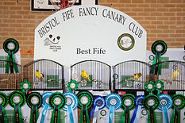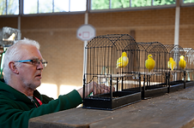

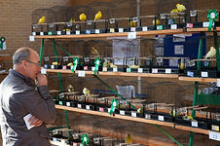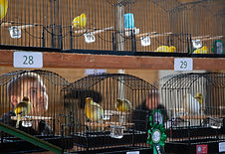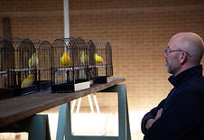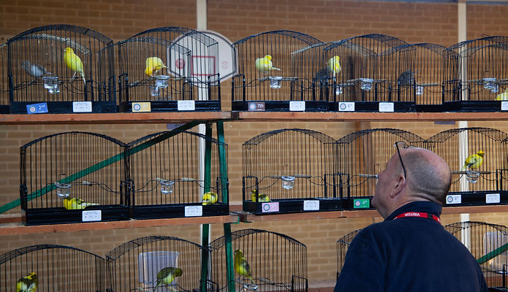

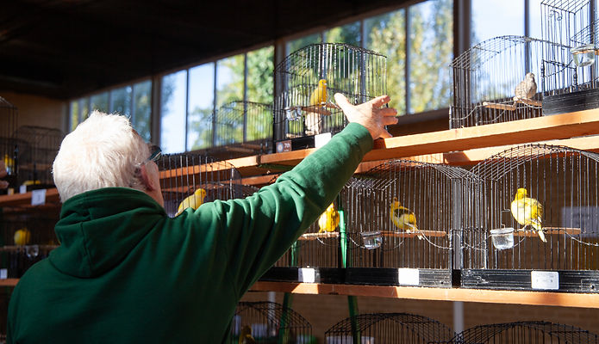

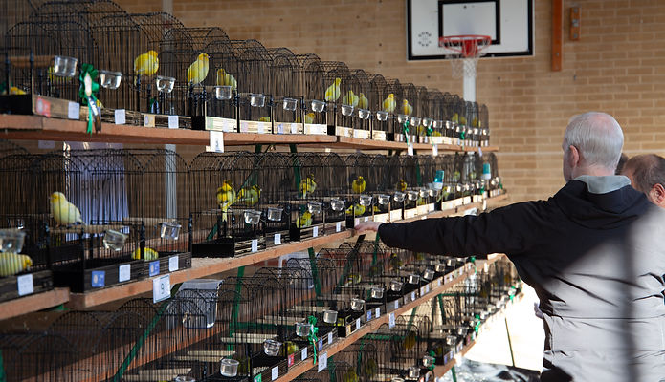

Directions from J17 M5

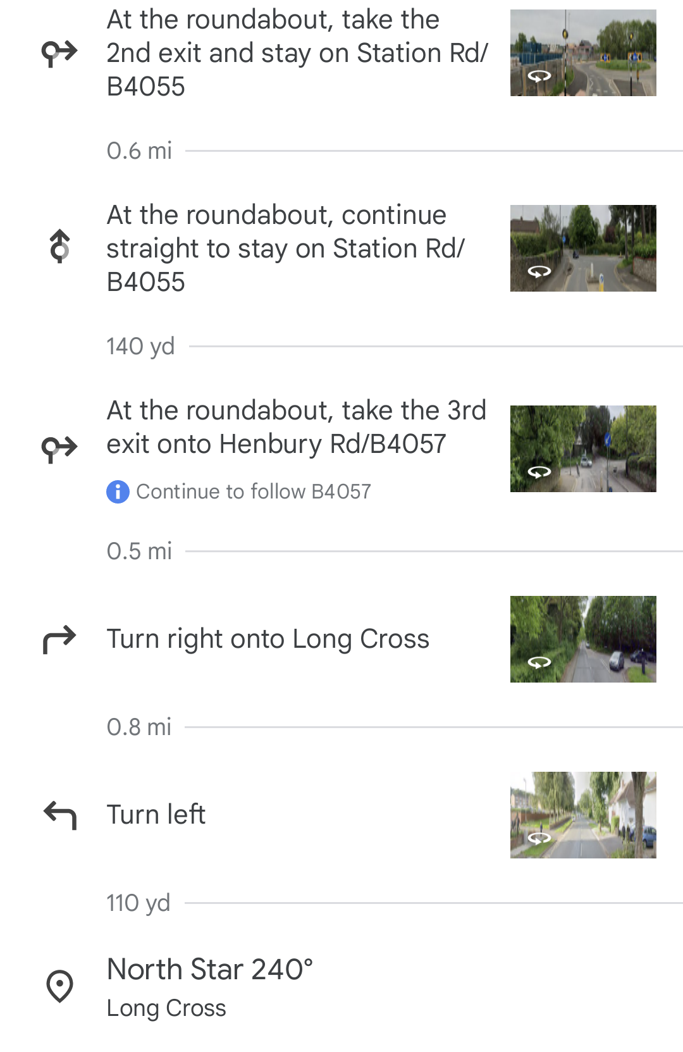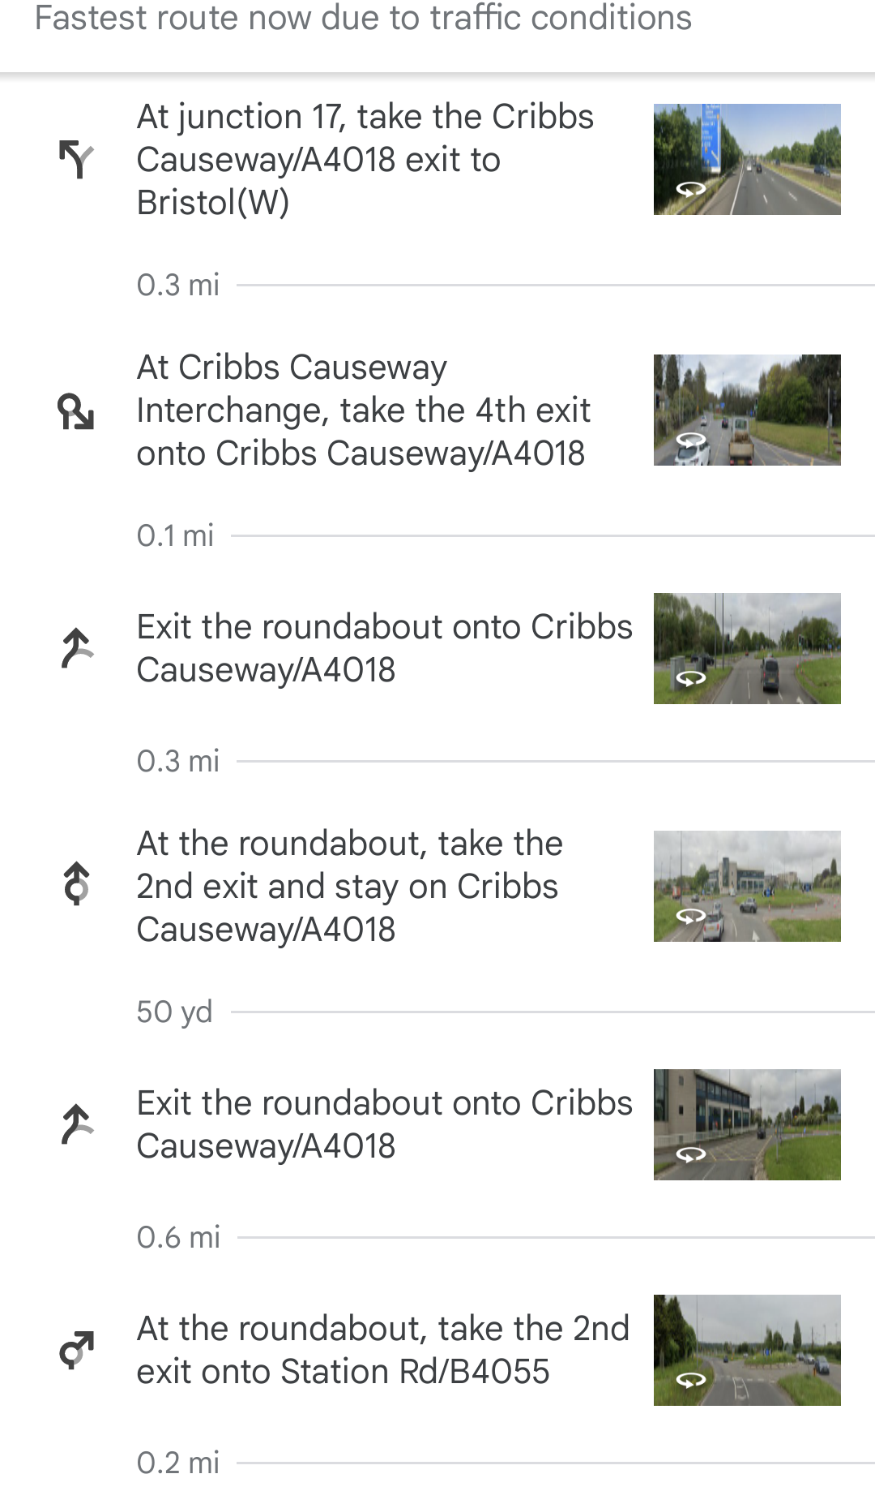

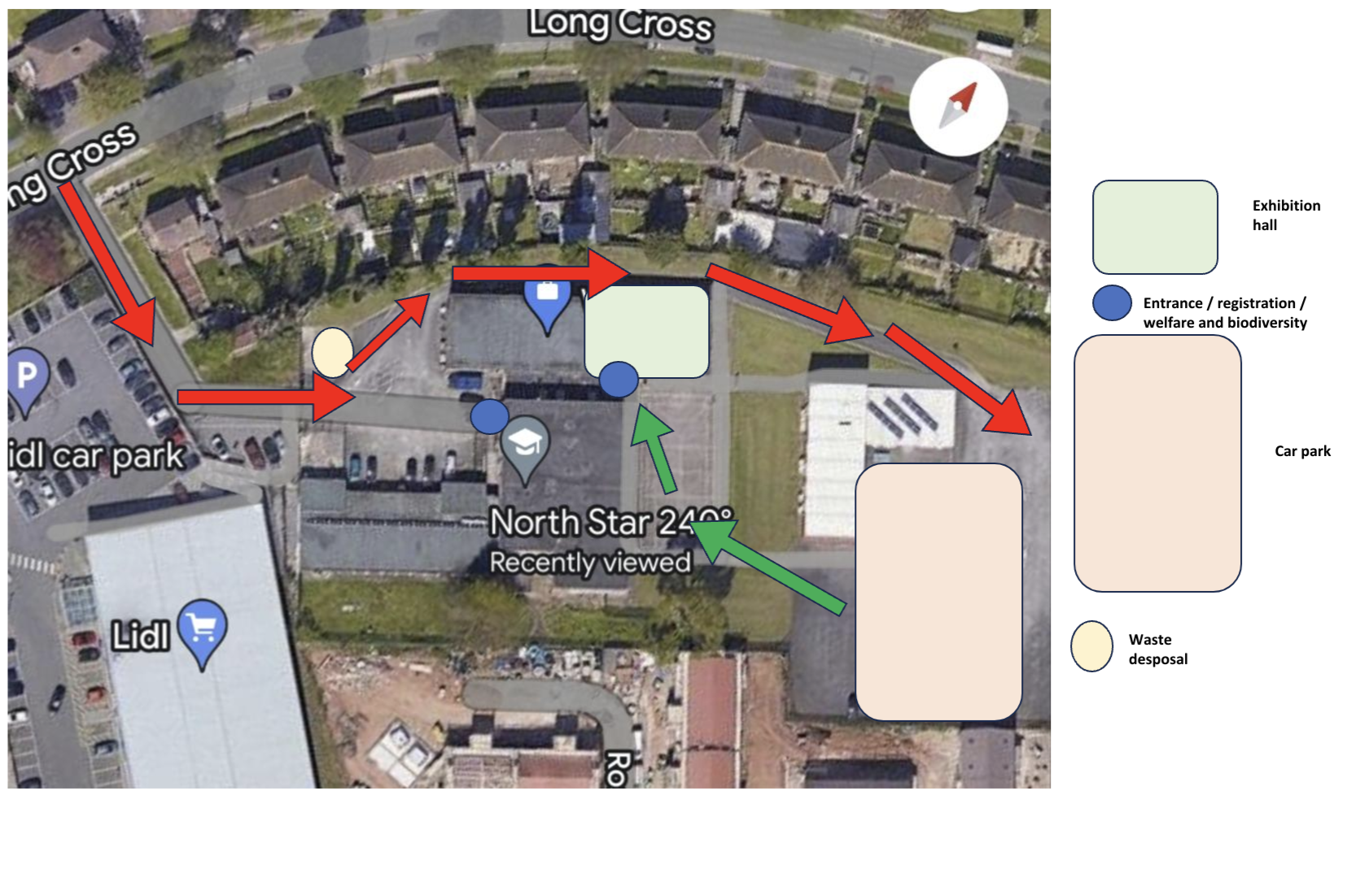

**Please either park in the Lidl car park, or follow the red arrows to the back of the premises.**

Bristol Fife Fancy Canary Club Show CERTIFICATE OF ENTRY

|  |  |  |
| --- | --- | --- |
| CLASS NUMBER | OFFICIAL USE ONLY | Descriptions |
|  |  |  |
|  |  |  |
|  |  |  |
|  |  |  |
|  |  |  |
|  |  |  |
|  |  |  |
|  |  |  |
|  |  |  |
|  |  |  |
|  |  |  |
|  |  |  |
|  |  |  |
|  |  |  |
|  |  |  |
|  |  |  |
|  |  |  |
|  |  |  |
|  |  |  |

|  |  |  |
| --- | --- | --- |
| Name ( BLOCK CAPITALS PLEASE) | Number of Entries @ £1.00 ea = |  |
| Address | Membership @ £5.00 (same for all)  Fife Canary Council Annual Membership @ £5.00  Full BFFCC and FCC Annual Membership @ £10.00 |  |
|  | Donations (Gratefully Received) |  |
| Post Code |  |  |
| Telephone Number | TOTAL | £ |
| Signed |  | |
| **Champion ◻** | **Novice ◻** | **Junior ◻** |

**Please make cheques payable to ‘Bristol Fife Fancy Canary Club’.**

**Paypal is accepted and payable to ‘bristolffcc@gmail.com’**

**You may also pay by bank transfer to ‘Bristol Fife Fancy Canary Club’**

**Account Number: 76563768 Sort Code: 30-99-50**

**Please send your entries with a self addressed and stamped envelope.**

**We are also happy for you to upload your entries using the online google**

**form on our facebook page.**

**All Entries to: Mr T Marsh,**

**24 Overhill, Pill, Bristol, BS20 0JZ**

**Phone Entries to Tom Marsh 07538159145**

**Emailed to: bristolffcc@gmail.com**

**HELP NEEDED ON THE DAY**

**To keep the show running smoothly and opening up on time, we need stewards to help with**

**checking in and during judging. Experienced or new exhibitors welcome.**

**Great chance to learn whilst working with our top class judges or just putting a little back into**

**the hobby. Those that want to get involved on the day please contact Tom Marsh on 07538159145.**

**Thank you to our main Sponsor for 2024**

A huge thank you to Shane Evans from Direct bird products for your support throughout the year!

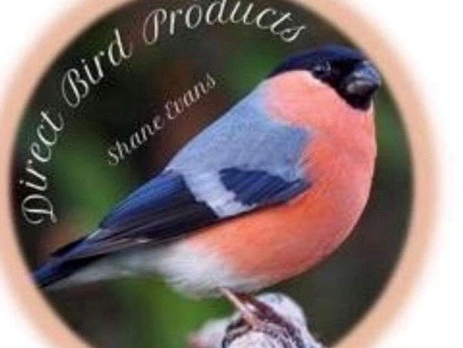



Join The Bristol Fife Fancy Canary Club to receive benefits such as club discount at Direct Bird Products.